Future sales prediction

Innovation:

In this project, our objective is to predict future sales accurately, enabling businesses to make informed decisions about inventory management, marketing strategies, and resource allocation. To introduce innovation into this future sales prediction project, we can integrate a recommendation system that suggests complementary products to customers based on their historical purchase behaviour.

challenges:

Overcoming data quality, seasonality, model selection, and feature engineering hurdles is crucial for precise sales forecasts using Python's powerful libraries.

solutions:

Python's powerful libraries help overcome data quality, seasonality, and model selection challenges by enabling meticulous data preprocessing, advanced modelling, and strategic feature engineering for precise sales forecasts.

Dataset and its details:

We carefully selected a dataset from Kaggle (www.kaggle.com) known for its accuracy and reliability. This dataset consists of historical sales data, including detailed product attributes, store information, and daily sales figures. It is well-maintained, up-to-date, and comes from a reputable source.

key columns from the dataset, including:

Date: To capture the temporal aspect of sales data.

Product ID: To identify individual products.

Sales Quantity: The target variable we aim to predict.

Price: To consider price fluctuations.

Store ID: To account for store-specific effects.

Promotions: To incorporate promotional campaigns as a feature.

Weather Data: External data to examine its impact on sales.

Train and test:

a. Data Preprocessing: Clean the dataset, handle missing values, and encode categorical variables.

b. Split Data: Divide the dataset into training and testing subsets (e.g., 80% for training, 20% for testing).

c. Model Selection: Choose a suitable algorithm (e.g., XGBoost, LSTM) based on the problem's nature.

d. Train the Model: Use the training data to train the selected model.

e.Test the Model: Evaluate the model's performance using metrics such as MAE, MSE, RMSE, and R2 on the testing dataset.

This system includes:

Purchase Complementarity Model: Develop a recommendation system that identifies frequently purchased product pairs.

Real-time Suggestions: Implement real-time recommendations when customers shop online.

Personalization: Customize suggestions for individual customers.

A/B Testing: Measure the impact of recommendations on sales through controlled experiments.

Feedback Loop: Allow customers to rate and improve recommendations.

This enhances sales forecasting accuracy and provides customers with personalized shopping experiences, potentially increasing sales and satisfaction.

Dataset Selection and Description:

For the "Future Sales Prediction" project, from kaggle dataset as a reference from future sales prediction by ML. The dataset contains crucial information, including historical sales data, product details, and time-related variables, all of which are pivotal in building an accurate prediction model.

Dataset Features: Describe the dataset features, their data types, and their relevance to the project.

Data Source: Provide a clear reference to the dataset source and its integrity.

Data Loading:

we begin by loading the dataset into our Python environment using the Pandas library. The code snippet below demonstrates how to do this:

import pandas as pd

# Load the dataset

dataset = pd.read_csv('your_dataset.csv')

# Display the initial data view

print(dataset.head())

Data Preprocessing:

Data preprocessing is a critical step to ensure the dataset is clean, complete, and ready for analysis and modelling. Here are some key preprocessing steps:

Handling Missing Values: Eliminate or impute missing values, if any.

Categorical Encoding: Transform categorical variables into numerical representations (e.g., one-hot encoding).

Numerical Scaling: Normalize or standardize numerical features, if required.

Code:

# Handle missing values (if any)

dataset.dropna(inplace=True)

# Encode categorical variables (if any)

dataset = pd.get_dummies(dataset, columns=['categorical_column'])

# Scale numerical features (if necessary)

from sklearn.preprocessing import StandardScaler

scaler = StandardScaler()

dataset['numerical_column'] = scaler.fit_transform(dataset['numerical_column'])

Data Analysis:

To gain insights into the dataset and prepare for future sales prediction, we conduct various analyses:

Exploratory Data Analysis (EDA): This phase involves understanding the data's distribution, trends, and central tendencies. Visualizations such as histograms and box plots can be effective in revealing data characteristics.

import seaborn as sns

import matplotlib.pyplot as plt

# Example: EDA with a histogram

sns.histplot(dataset['sales'])

plt.xlabel('Sales')

plt.ylabel('Frequency')

plt.title('Sales Distribution')

plt.show()

Time Series Analysis: If applicable, time series data can be decomposed to identify trends, seasonality, and noise. Autocorrelation and partial autocorrelation plots can help in understanding temporal dependencies.

from statsmodels.tsa.seasonal import seasonal_decompose

# Decompose time series

result = seasonal_decompose(dataset['sales'], model='additive')

result.plot()

plt.show()

Feature Engineering:

Creating new features and lag features can be beneficial in capturing historical information and improving prediction models.

# Example: Create lag features

dataset['sales_lag_1'] = dataset['sales'].shift(1)

dataset['sales_lag_7'] = dataset['sales'].shift(7)

These phases and code examples lay the foundation for our Future Sales Prediction project. The specific modelling and forecasting steps will follow in subsequent project phases.

This post is divided into two parts: EDA & Forecasting.

Program and outputs:

# Part A) Exploratory Data Analysis (EDA)

Let’s start by first importing the required libraries followed by data exploration.

# Importing required libraries  
import numpy as np  
import pandas as pd, datetime  
import seaborn as sns

from statsmodels.tsa.stattools import adfuller  
import matplotlib.pyplot as plt  
get_ipython().run_line_magic('matplotlib', 'inline')  
from time import time  
import os  
from math import sqrt  
from statsmodels.tsa.seasonal import seasonal_decompose  
from statsmodels.graphics.tsaplots import plot_acf, plot_pacf  
import itertools  
import statsmodels.api as sm  
from statsmodels.tsa.stattools import acf,pacf  
from statsmodels.tsa.arima_model import ARIMA  
from sklearn import model_selection  
from sklearn.metrics import mean_squared_error, r2_score  
from pandas import DataFrame  
import xgboost as xgb  
from fbprophet import Prophet  
import warnings  
warnings.filterwarnings('ignore')# Importing store data  
store = pd.read_csv('./data/store.csv')  
store.head()

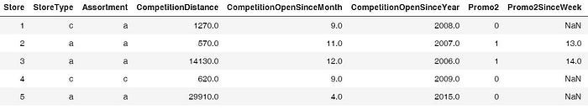

The above table gives us information about 1115 stores owned.  
train = pd.read_csv('./data/train.csv', index_col='Date', parse_dates = True)  
train.head()

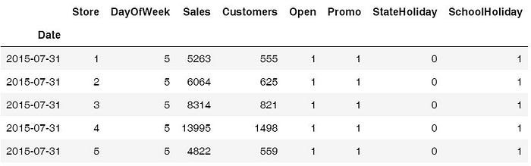

We can see from the above table that the date is one of the columns. this is a time-series data.

1. Trends & Seasonality

Let’s see how the sales vary with month, promo, promo2 and year.

# Sales trend over the months and year  
sns.factorplot(data = train_store_joined, x ="Month", y = "Sales",   
 col = 'Promo', # per store type in cols  
 hue = 'Promo2',  
 row = "Year")

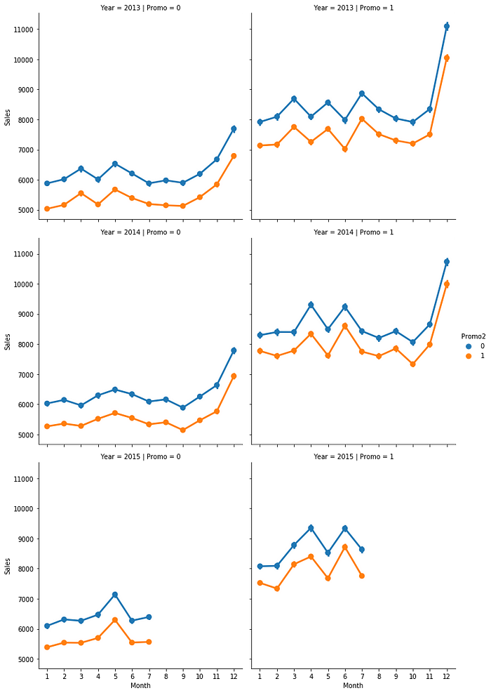

The above graph tells us that sales tend to spike in December, which makes sense because of the Christmas and holiday season. So, this confirms that the sales vary with the ‘Date’ (time) and there is a seasonality factor present in our data.

# Sales trend over days  
sns.factorplot(data = train_store_joined, x = "DayOfWeek", y = "Sales", hue = "Promo")

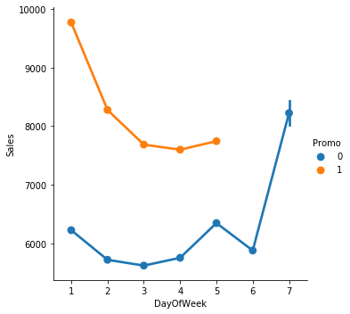

The sales tend to increase on Sunday because people shop during the weekend.

2. Stationarity of Time Series

In order to use time series forecasting models, we need to ensure that our time series data is stationary.

Let’s check the stationarity of a store of type ‘a’.

# Data Preparation: input should be float type  
train['Sales'] = train['Sales'] * 1.0# Assigning one store from each category  
sales_a = train[train.Store == 2]['Sales']# Trend  
sales_a.resample('W').sum().plot(ax = ax1)

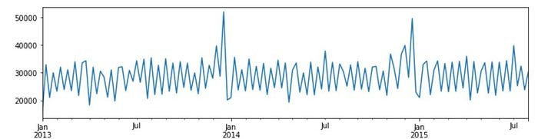

The above graph tells us that sales tend to peak at the end of the year.  
 # Determing rolling statistics  
 roll_mean = timeseries.rolling(window=7).mean()  
 roll_std = timeseries.rolling(window=7).std()# Plotting rolling statistics:  
 orig = plt.plot(timeseries.resample('W').mean(), color='blue',label='Original')  
 mean = plt.plot(roll_mean.resample('W').mean(), color='red', label='Rolling Mean')  
 std = plt.plot(roll_std.resample('W').mean(), color='green', label = 'Rolling Std')  
 plt.legend(loc='best')  
 plt.show(block=False)  
 # Performing Dickey-Fuller test:  
 print('Results of Dickey-Fuller Test:')  
 result = adfuller(timeseries, autolag='AIC')  
 print('ADF Statistic: %f' % result[0])  
 print('p-value: %f' % result[1])  
 print('Critical Values:')  
 for key, value in result[4].items():  
 print(key, value)# Testing stationarity of store type a  
test_stationarity(sales_a)

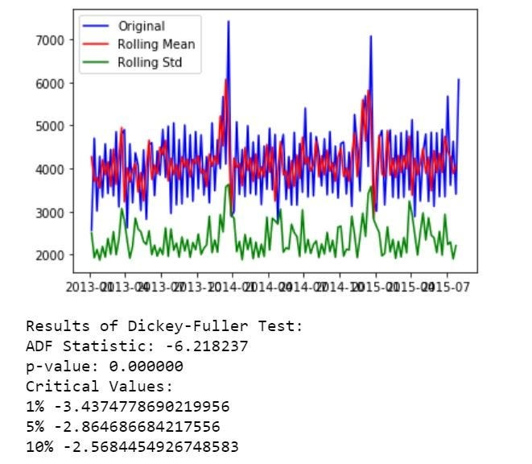

Now, let’s see the seasonality and trend using decomposition plots.

# Plotting seasonality and trend  
def plot_timeseries(sales,StoreType):fig, axes = plt.subplots(2, 1, sharex=True, sharey=False)  
 fig.set_figheight(10)  
 fig.set_figwidth(15)decomposition= seasonal_decompose(sales, model = 'additive',freq=365)estimated_trend = decomposition.trend  
 estimated_seasonal = decomposition.seasonal  
 estimated_residual = decomposition.resid  
 axes[1].plot(estimated_seasonal, 'g', label='Seasonality')  
 axes[1].legend(loc='upper left');  
 axes[0].plot(estimated_trend, label='Trend')  
 axes[0].legend(loc='upper left');plt.title('Decomposition Plots')

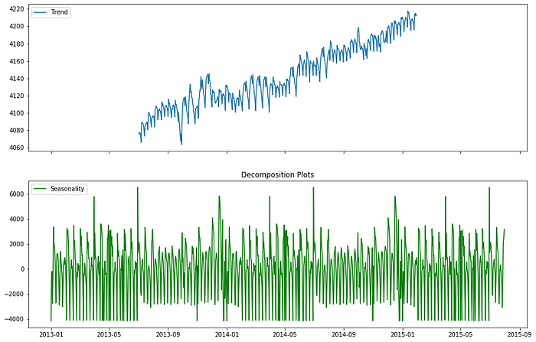

From the above plots, we can see that there are seasonality and tr

end present in our data. So, we’ll use the forecasting models that take both of these factors into consideration.

# Part B) Forecasting: Predictive Modelling

Evaluation Metrics

There are two popular metrics used in measuring the performance of regression models i.e. MAE & RMSE.

Mean Absolute Error (MAE): It is the average of the absolute difference between the predicted values and observed values.

Root Mean Square Error (RMSE): It is the square root of the average of squared differences between the predicted values and observed values.

Predictive Modelling

Model 1: Autoregressive Integrated Moving Average (ARIMA)

We will use one of the most commonly used methods for time-series forecasting, known as ARIMA.

ARIMA models are denoted by ARIMA(p, d, q).

p, d, and q represent seasonality, trend, and noise in data respectively. We’ll first create all possible combinations of p, d, and q as follows:

# Define the p, d and q parameters to take any value between 0 and 3  
p = d = q = range(0, 2)# Generate all different combinations of p, q and q triplets  
pdq = list(itertools.product(p, d, q))# Generate all different combinations of seasonal p, q and q triplets  
seasonal_pdq = [(x[0], x[1], x[2], 12) for x in list(itertools.product(p, d, q))]print('Examples of parameter combinations for Seasonal ARIMA: ')  
print('SARIMAX: {} x {}'.format(pdq[1], seasonal_pdq[1]))  
print('SARIMAX: {} x {}'.format(pdq[1], seasonal_pdq[2]))  
print('SARIMAX: {} x {}'.format(pdq[2], seasonal_pdq[3]))  
print('SARIMAX: {} x {}'.format(pdq[2], seasonal_pdq[4]))

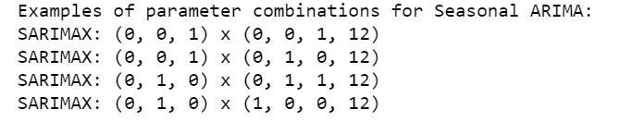

Hyperparameter tuning for ARIMA:

# Determing p,d,q combinations with AIC scores.  
for param in pdq:  
 for param_seasonal in seasonal_pdq:  
 try:  
 mod = sm.tsa.statespace.SARIMAX(train_arima,  
 order=param,  
 seasonal_order=param_seasonal,  
 enforce_stationarity=False,  
 enforce_invertibility=False)results = mod.fit()print('ARIMA{}x{}12 - AIC:{}'.format(param, param_seasonal, results.aic))  
 except:  
 continue

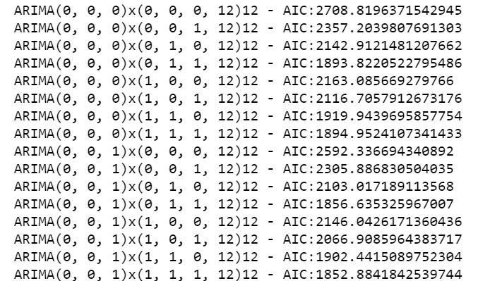

I’ve only included a snapshot of how the grid search looks. The above iteration suggested that SARIMAX(1, 1, 1)x(0, 1, 1, 12)12 is the best parameter combination with the lowest AIC: 1806.29.

Fitting the ARIMA model

# Fitting the data to ARIMA model   
model_sarima = sm.tsa.statespace.SARIMAX(train_arima,  
 order=(1, 1, 1),  
 seasonal_order=(0, 1, 1, 12),  
 enforce_stationarity=False,  
 enforce_invertibility=False)results_sarima = model_sarima.fit()print(results_sarima.summary().tables[1])

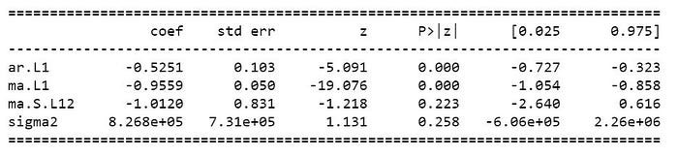

Let’s check diagnostic plots to visualize the performance of our model.# Checking diagnostic plotsresults_sarima.plot_diagnostics(figsize=(10, 10))plt.show()

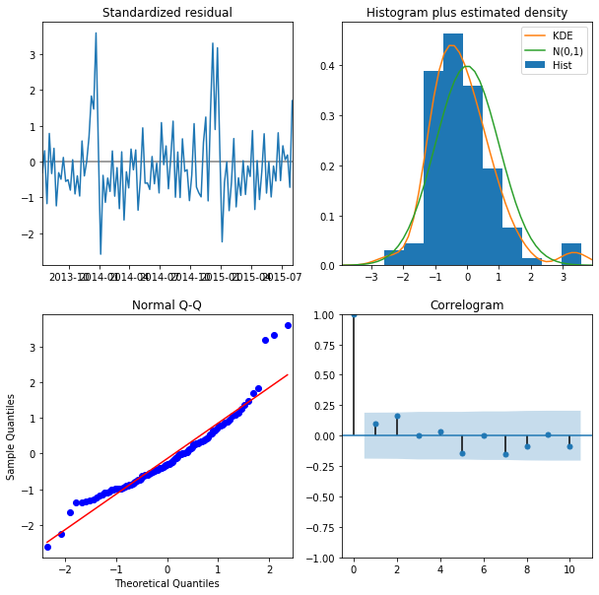

The Normal Q-Q plot shows that the ordered distribution of residuals follows the distribution similar to normal distribution. Thus, our model seems to be pretty good.

Model Prediction:

# Model Prediction  
# Predictions are performed for the 11th Jan' 2015 onwards of the train data.pred = results_sarima.get_prediction(start=pd.to_datetime('2015-01-11'), dynamic = False)# Get confidence intervals of forecasts  
pred_ci = pred.conf_int()ax = train_arima["2014":].plot(label = "observed", figsize=(15, 7))  
pred.predicted_mean.plot(ax = ax, label = "One-step ahead Forecast", alpha = 1)  
ax.fill_between(pred_ci.index,   
 pred_ci.iloc[:, 0],   
 pred_ci.iloc[:, 1],   
 color = "k", alpha = 0.05)ax.set_xlabel("Date")  
ax.set_ylabel("Sales")plt.legend  
plt.show()train_arima_forecasted = pred.predicted_mean  
train_arima_truth = train_arima["2015-01-11":]# Calculating the error  
rms_arima = sqrt(mean_squared_error(train_arima_truth, train_arima_forecasted))  
print("Root Mean Squared Error: ", rms_arima)

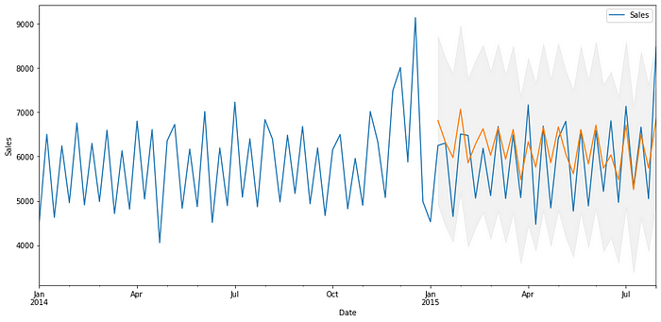



The above plot shows that our predicted values catch up to the observed values in the dataset. Our forecasts seem to align with the ground truth very well and show a spike in December as expected. RMSE is also reasonably low in our case.

So, final ARIMA model can be represented as SARIMAX(1, 1, 1)x(0, 1, 1, 12)12. This is the best we can do with ARIMA, so let’s try another model to see whether we can decrease the RMSE.

Model 2: Prophet

Prophet is an open-source tool by Facebook. This procedure is used for forecasting time series data based on an additive model where non-linear trends are fit with yearly, weekly, and daily seasonality, plus holiday effects.

Baseline model

Our baseline (initial) model will use the default parameters. Let’s see how it performs.names to specific names as required by Prophet library  
train_prophet = train_prophet.rename(columns = {'Date': 'ds',  
 'Sales': 'y'})# Downsampling to week because modelling on daily basis takes a lot of time  
ts_week_prophet = train_prophet.set_index("ds").resample("W").sum()

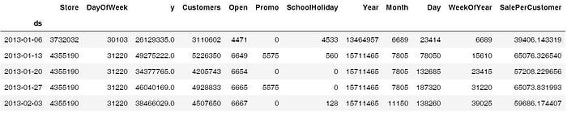

Visualizing predictions forecast  
prophet.plot(forecast_1):

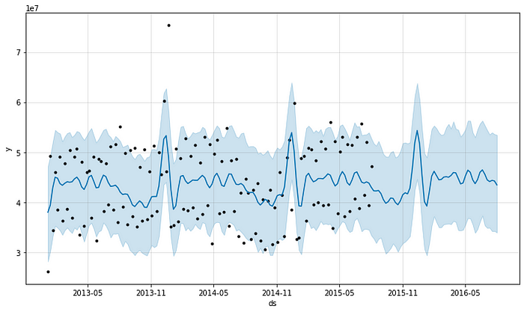

We can see from the above plot that the predictions are decent enough but let’s look at the RMSE to get a better idea.

# Checking the RMSE of Prophet model  
metric_prophet_1 = forecast_1.set_index('ds')[['yhat']].join(ts_week_prophet_train.set_index('ds').y).reset_index()  
metric_prophet_1.dropna(inplace=True)  
rms_prophet_1 = mean_squared_error(metric_prophet_1.y, metric_prophet_1.yhat)  
rms_prophet_1



# Encoding state holiday categorical variable  
train_prophet["StateHoliday_cat"] = train_prophet["StateHoliday"].map({0:0, "0": 0, "a": 1, "b": 1, "c": 1})# Choosing only required cols  
train_prophet = train_prophet[['ds', 'y', 'SchoolHoliday', 'StateHoliday_cat']]  
train_prophet.head()

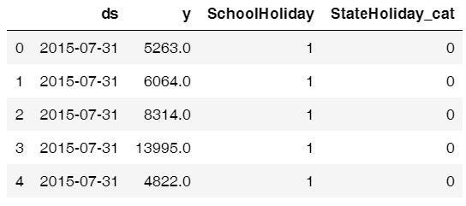

# Modelling holidays - creating holidays dataframe  
state_dates = train_prophet[(train_prophet.StateHoliday_cat == 1)].loc[:, "ds"].values  
school_dates = train_prophet[(train_prophet.SchoolHoliday == 1)].loc[:, "ds"].valuesstate = pd.DataFrame({"holiday": "state_holiday", "ds": pd.to_datetime(state_dates)})  
school = pd.DataFrame({"holiday": "school_holiday", "ds": pd.to_datetime(school_dates)})holidays = pd.concat((state, school))  
holidays.head()# Dropping holiday columns because not needed any more  
train_prophet_clean = train_prophet.drop(["SchoolHoliday", "StateHoliday_cat"], axis = 1)# Downsampling to week because modelling on daily basis takes a lot of time  
ts_week_prophet = train_prophet_clean.set_index("ds").resample("W").sum()# Resetting the index  
ts_week_prophet_train = ts_week_prophet.reset_index()

Model Prediction:

future_2 = prophet_2.make_future_dataframe(periods = 52, freq = "W")   
forecast_2 = prophet_2.predict(future)  
forecast_2[["ds", "yhat", "yhat_lower", "yhat_upper"]].tail() # We have a new dataframe, which includes, the forecast and the uncertainity invervals.

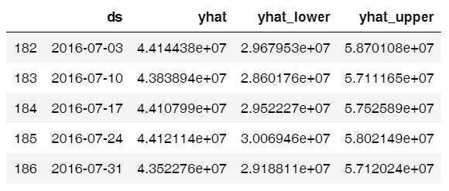

# Visualizing predicions of forecast  
prophet.plot(forecast_2);

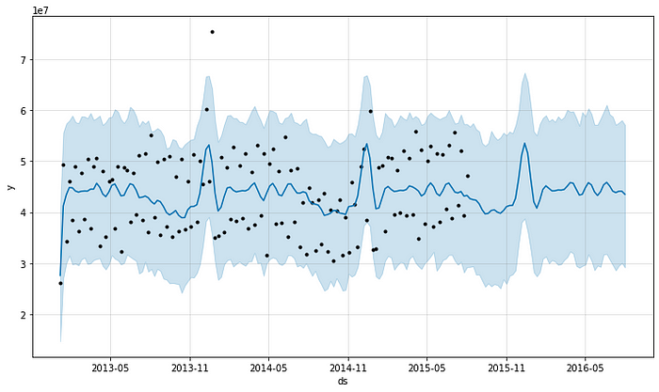

# Visualizing trend and seasonality components  
prophet.plot_components(forecast_2);

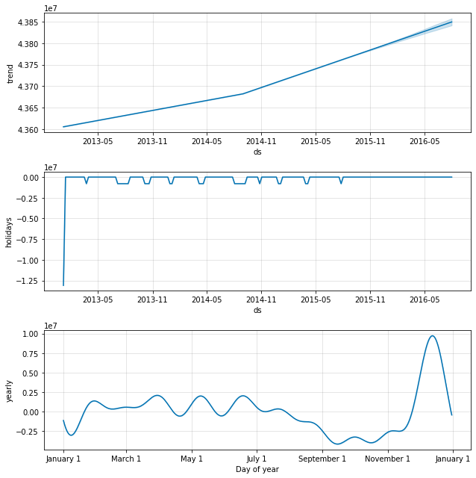

The first plot shows that the total sales on a weekly basis are increasing. The second plot shows the holiday gaps in the dataset and the third plot shows that the store sees very high sales in the last week of December (because of the Christmas holidays).

# Checking the RMSE of Prophet model  
metric_prophet_2 = forecast_2.set_index('ds')[['yhat']].join(ts_week_prophet_train.set_index('ds').y).reset_index()  
metric_prophet_2.dropna(inplace=True)  
rms_prophet_2 = mean_squared_error(metric_prophet_2.y, metric_prophet_2.yhat)  
rms_prophet_2



**Model 3: XGBoost**

XGBoost is an optimized distributed gradient boosting library designed to be highly **efficient, flexible and portable.** Although it is not specifically designed for time-series data, it is known to perform extremely well in all kinds of regression problems.

# Dropping Customers and Sale per customer  
ts_xgboost = train_store_joined.copy()  
ts_xgboost = ts_xgboost.drop(['Customers', 'SalePerCustomer', 'PromoInterval'], axis=1)# Combining similar columns into one column and dropping old columns  
ts_xgboost['CompetitionOpen'] = 12 * (ts_xgboost.Year - ts_xgboost.CompetitionOpenSinceYear) + (ts_xgboost.Month - ts_xgboost.CompetitionOpenSinceMonth)  
ts_xgboost['PromoOpen'] = 12 * (ts_xgboost.Year - ts_xgboost.Promo2SinceYear) + (ts_xgboost.WeekOfYear - ts_xgboost.Promo2SinceWeek) / 4.0  
ts_xgboost = ts_xgboost.drop(["CompetitionOpenSinceMonth", "CompetitionOpenSinceYear"], axis = 1)  
ts_xgboost = ts_xgboost.drop(["Promo2SinceWeek", "Promo2SinceYear"], axis = 1)# Converting categorical cols to numerical cols and removing old cols  
mappings = {0:0, "0": 0, "a": 1, "b": 1, "c": 1}  
ts_xgboost["StateHoliday_cat"] = ts_xgboost["StateHoliday"].map(mappings)  
ts_xgboost["StoreType_cat"] = ts_xgboost["StoreType"].map(mappings)  
ts_xgboost["Assortment_cat"] = ts_xgboost["Assortment"].map(mappings)  
ts_xgboost = ts_xgboost.drop(["StateHoliday", "StoreType", "Assortment"], axis = 1)# Splitting the data  
features = ts_xgboost.drop(["Sales"], axis = 1)  
target = ts_xgboost["Sales"]X_train, X_test, y_train, y_test = model_selection.train_test_split(features, target, test_size = 0.

Let’s see what features impact the sales of a store.

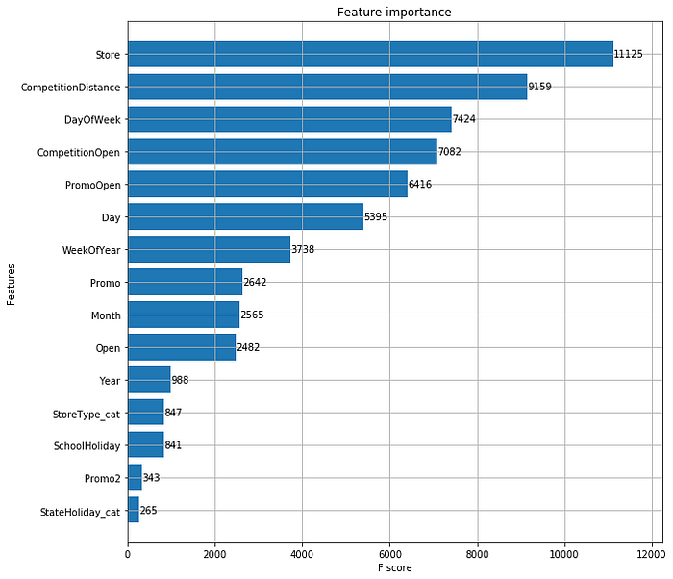

As expected, there are five major reasons affecting the sales of a store viz. the **number of stores, competition distance, day of the week, is the competition open, and promotions**.

Our final XGBoost model after hyper tuning is the one with **‘max_depth’:10, ‘eta’:0.1, ‘gamma’: 2 and RMSE score of 1191.90**, which is great! Now, let's compare the performance of all models

Results:

We used the Root Mean Squared Error (RMSE) to evaluate and validate the performance of various models. Let’s see which model performed better and why/why not.

# Comparing performance of above three models - through RMSE  
rms_arima = format(float(rms_arima))  
rms_prophet_2 = format(float(rms_prophet_2))  
rms_xgboost_2 = format(float(rms_xgboost_2))model_errors = pd.DataFrame({  
 "Model": ["SARIMA", "Prophet", "XGBoost"],  
 "RMSE": [rms_arima, rms_prophet_2, rms_xgboost_2]  
})model_errors.sort_values(by = "RMSE")

Conclusion:

* The most interesting thing about the data was that the category of stores having the highest sales didn’t have the highest sale per customer. It might be because those stores sell small items, which are needed on a daily basis.
* Another interesting thing is probably because customers already purchased whatever they wanted during the first promotional sale.